# Channel in Slack: #hardware_oracle
# Direct link to it: https://join.slack.com/share/zt-hbux22gi-xV04wU6Pfb9AFj~SdWd_oA

https://jira.tcsbank.ru/browse/INCR-163
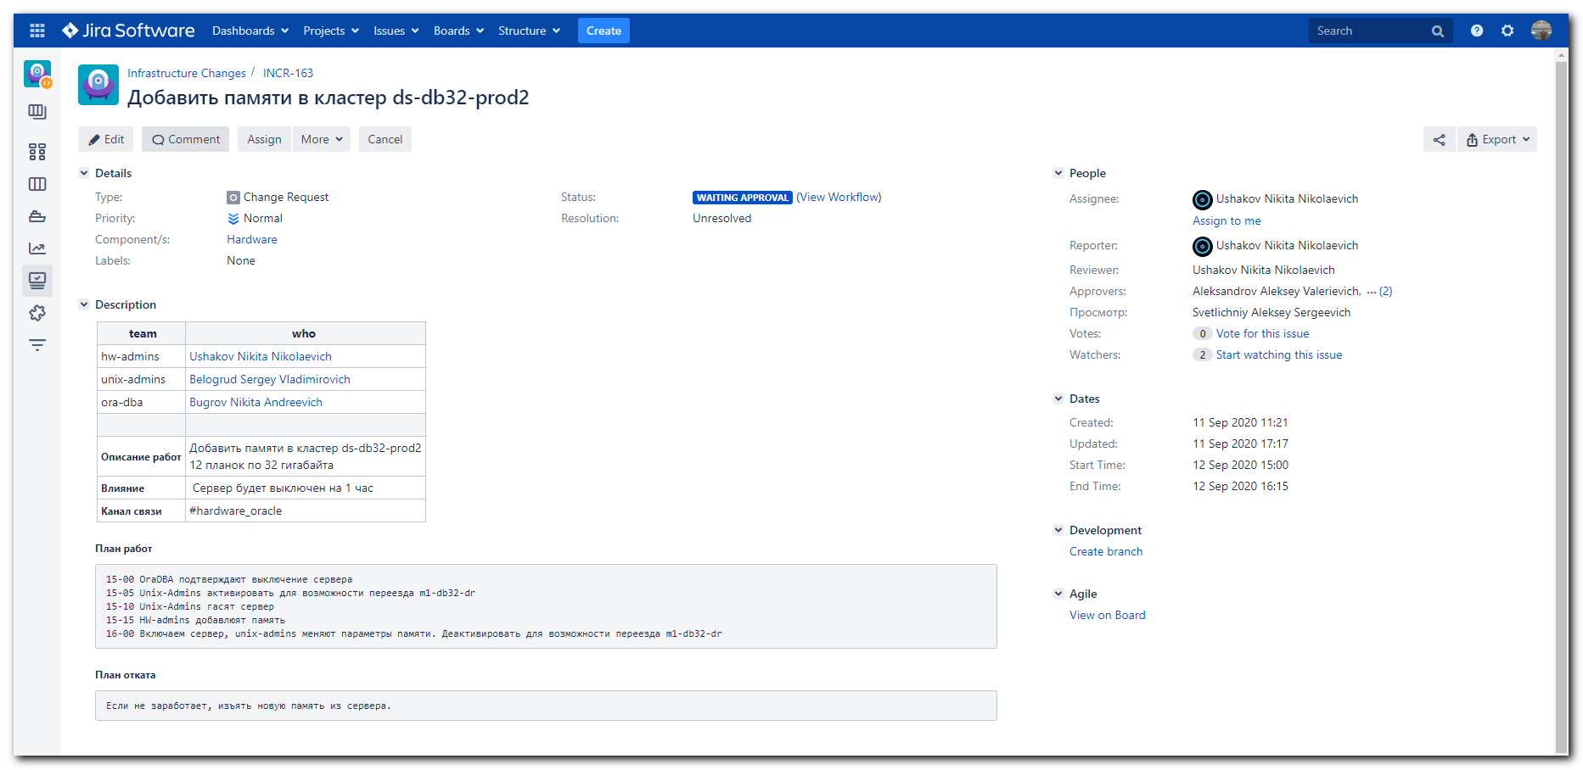

Александров Алексей 5:18 PM
Серега посмотри работы на СБ. Там память добавлять будут. https://jira.tcsbank.ru/browse/INCR-163

Белогруд Сергей:house_with_garden: 5:29 PM
Смотрю.

Александров Алексей 5:31 PM
По последнему пункту где нужно поменять параметры памяти. Для этого нужно выполнить команду:
ansible-playbook oracle.yml -b -K --tags tuning --diff -l <host_name>
5:32
Репозиторий - https://vm-gitlab01.tcsbank.ru/jet/ansible
5:33
Прежде изменения можно прочекать с опцией --check, ну ты и сам знаешь

Белогруд Сергей:house_with_garden: 5:34 PM
Вот это "15-05 Unix-Admins активировать для возможности переезда m1-db32-dr" чем делается?

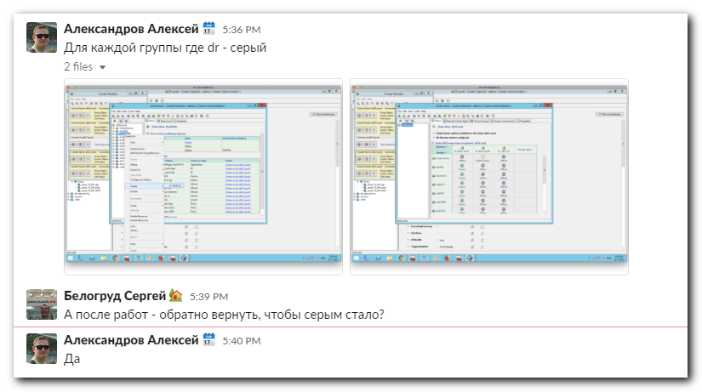

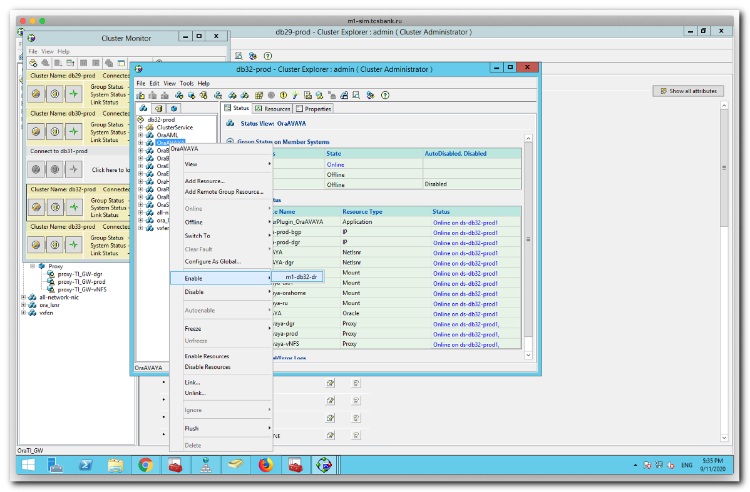
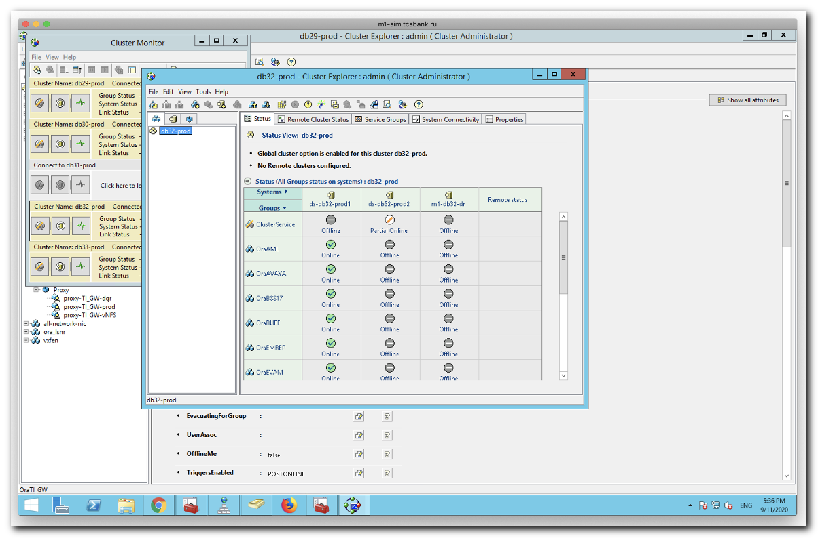

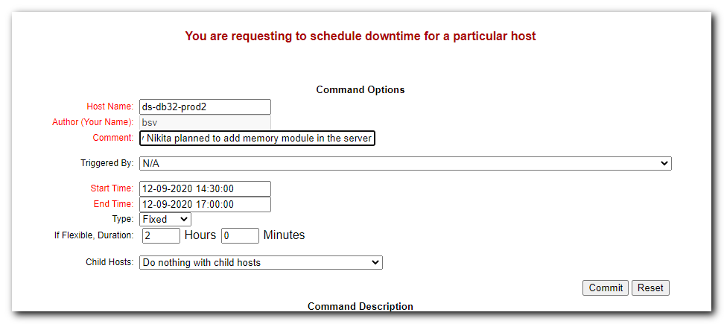

#
# 20200911
# Here I tested how this playbook work and connection exists.
#

[support@centos jet]$ ansible-playbook oracle.yml -i list_of_hosts --become --tags tuning --diff --extra-vars "ansible_user=bsv ansible_password=$(pass common/linux) ansible_sudo_pass=$(pass common/linux) ansible_ssh_common_args='-oStrictHostKeyChecking=no -oPubkeyAuthentication=no -oUserKnownHostsFile=/dev/null'" --check | tee -a ./output/$(date +%Y%m%d-%H%M).playbook.log.txt
gpg: Invalid passphrase; please try again ...
[WARNING] Ansible is being run in a world writable directory (/mnt/share/work/vm-gitlab01.tcsbank.ru/jet), ignoring it as an ansible.cfg source. For more information see https://docs.ansible.com/ansible/devel/reference_appendices/config.html#cfg-in-world-writable-dir
[WARNING]: file /mnt/share/work/vm-gitlab01.tcsbank.ru/jet/roles/oracle/tasks/add_di.yml is empty and had no tasks to include

PLAY [all] *******************************************************************************************************************************************************************

TASK [Gathering Facts] *******************************************************************************************************************************************************
ok: [ds-db32-prod2.tcsbank.ru]

TASK [oracle : Oracle OS sysctl tuning] **************************************************************************************************************************************
ok: [ds-db32-prod2.tcsbank.ru] => (item={'value': 500, 'key': u'vm.dirty_expire_centisecs'})
ok: [ds-db32-prod2.tcsbank.ru] => (item={'value': 0, 'key': u'vm.dirty_ratio'})
ok: [ds-db32-prod2.tcsbank.ru] => (item={'value': 0, 'key': u'vm.dirty_background_ratio'})
ok: [ds-db32-prod2.tcsbank.ru] => (item={'value': u'256 131072 100 512', 'key': u'kernel.sem'})
ok: [ds-db32-prod2.tcsbank.ru] => (item={'value': 4096, 'key': u'kernel.shmmni'})
ok: [ds-db32-prod2.tcsbank.ru] => (item={'value': 6815744, 'key': u'fs.file-max'})
ok: [ds-db32-prod2.tcsbank.ru] => (item={'value': 3145728, 'key': u'fs.aio-max-nr'})
ok: [ds-db32-prod2.tcsbank.ru] => (item={'value': 2147483648, 'key': u'vm.dirty_bytes'})
ok: [ds-db32-prod2.tcsbank.ru] => (item={'value': 1, 'key': u'vm.swappiness'})
ok: [ds-db32-prod2.tcsbank.ru] => (item={'value': 0, 'key': u'kernel.numa_balancing'})
ok: [ds-db32-prod2.tcsbank.ru] => (item={'value': u'9000 65001', 'key': u'net.ipv4.ip_local_port_range'})
ok: [ds-db32-prod2.tcsbank.ru] => (item={'value': 209715200, 'key': u'vm.dirty_background_bytes'})

TASK [oracle : Set shmmax = (RAM in bytes - 1)] ******************************************************************************************************************************
changed: [ds-db32-prod2.tcsbank.ru]

TASK [oracle : Set shmall = ((shmmax - 1GB) / shmni))] ***********************************************************************************************************************
changed: [ds-db32-prod2.tcsbank.ru]

TASK [oracle : Set Huge Pages = (default 80%) RAM] ***************************************************************************************************************************
changed: [ds-db32-prod2.tcsbank.ru]

TASK [oracle : Set vm.min_free_kbytes] ***************************************************************************************************************************************
skipping: [ds-db32-prod2.tcsbank.ru]

TASK [oracle : oracle limits tuning] *****************************************************************************************************************************************
skipping: [ds-db32-prod2.tcsbank.ru] => (item={u'type': u'soft', u'limit': u'nofile', u'value': 1048576})
skipping: [ds-db32-prod2.tcsbank.ru] => (item={u'type': u'hard', u'limit': u'nofile', u'value': 1048576})
skipping: [ds-db32-prod2.tcsbank.ru] => (item={u'type': u'soft', u'limit': u'nproc', u'value': 1048576})
skipping: [ds-db32-prod2.tcsbank.ru] => (item={u'type': u'hard', u'limit': u'nproc', u'value': 1048576})
skipping: [ds-db32-prod2.tcsbank.ru] => (item={u'type': u'soft', u'limit': u'stack', u'value': 10240})
skipping: [ds-db32-prod2.tcsbank.ru] => (item={u'type': u'hard', u'limit': u'stack', u'value': 32768})
skipping: [ds-db32-prod2.tcsbank.ru] => (item={u'type': u'soft', u'limit': u'memlock', u'value': u'356153241'})
skipping: [ds-db32-prod2.tcsbank.ru] => (item={u'type': u'hard', u'limit': u'memlock', u'value': u'356153241'})

PLAY RECAP *******************************************************************************************************************************************************************
ds-db32-prod2.tcsbank.ru : ok=5 changed=3 unreachable=0 failed=0 skipped=2 rescued=0 ignored=0

[support@centos jet]$

# To fuck follow message
[WARNING] Ansible is being run in a world writable directory (/mnt/share/work/vm-gitlab01.tcsbank.ru/jet), ignoring it as an ansible.cfg source. For more information see https://docs.ansible.com/ansible/devel/reference_appendices/config.html#cfg-in-world-writable-dir
# Require to do follow.

[support@centos jet]$ cat ansible.cfg
[defaults]
inventory = ./production
deprecation_warnings = False
host_key_checking = False
stdout_callback = default
hash_behaviour = merge
retry_files_enabled = False
[support@centos jet]$ export ANSIBLE_CONFIG=ansible.cfg ; ansible-playbook oracle.yml -i list_of_hosts --become --tags tuning --diff --extra-vars "ansible_user=bsv ansible_password=$(pass common/linux) ansible_sudo_pass=$(pass common/linux) ansible_ssh_common_args='-oStrictHostKeyChecking=no -oPubkeyAuthentication=no -oUserKnownHostsFile=/dev/null'" --check | tee -a ./output/$(date +%Y%m%d-%H%M).playbook.log.txt
[WARNING]: file /mnt/share/work/vm-gitlab01.tcsbank.ru/jet/roles/oracle/tasks/add_di.yml is empty and had no tasks to include

PLAY [all] *******************************************************************************************************************************************************************

TASK [Gathering Facts] *******************************************************************************************************************************************************
ok: [ds-db32-prod2.tcsbank.ru]
...

https://docs.ansible.com/ansible/devel/reference_appendices/config.html#cfg-in-world-writable-dir
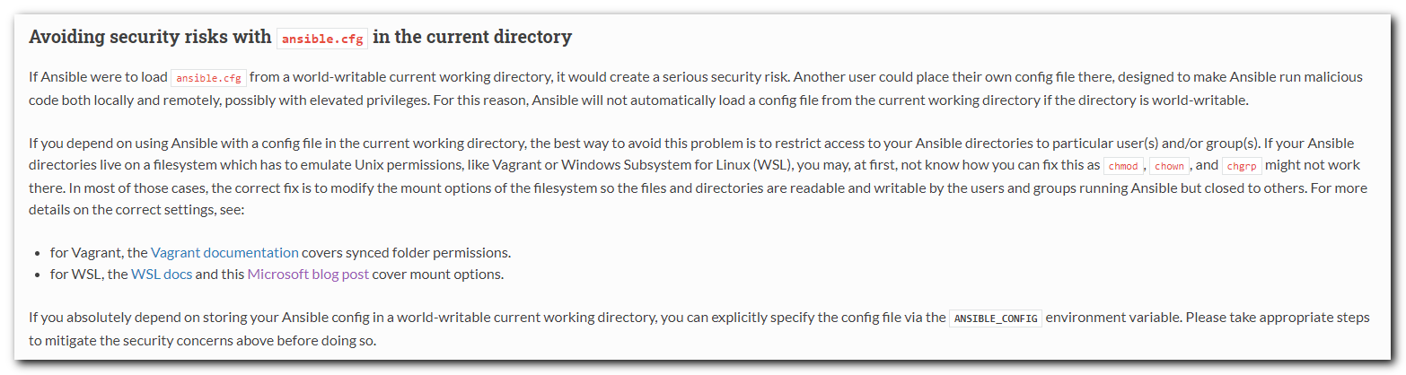

# In my case for Virtualbox, I cannot change permission for directory, shared from ms windows host.
[support@centos shell]$ find ../../vm-gitlab01.tcsbank.ru/ -type f -iname ansible.cfg
../../vm-gitlab01.tcsbank.ru/jet/ansible.cfg
[support@centos shell]$
[support@centos shell]$ chmod 775 ../../vm-gitlab01.tcsbank.ru/jet/
[support@centos shell]$ ls -Alhd ../../vm-gitlab01.tcsbank.ru/jet/
drwxrwxrwx 1 root root 8.0K Sep 11 18:07 ../../vm-gitlab01.tcsbank.ru/jet/
[support@centos shell]$
[root@centos ~]# cat /etc/fstab
...
share /mnt/share vboxsf defaults 0 0
...
[root@centos ~]#

# But from WSL (Ubuntu 16.04 installed under ms windows 10), - it could be possible, as I read.
https://devblogs.microsoft.com/commandline/chmod-chown-wsl-improvements/
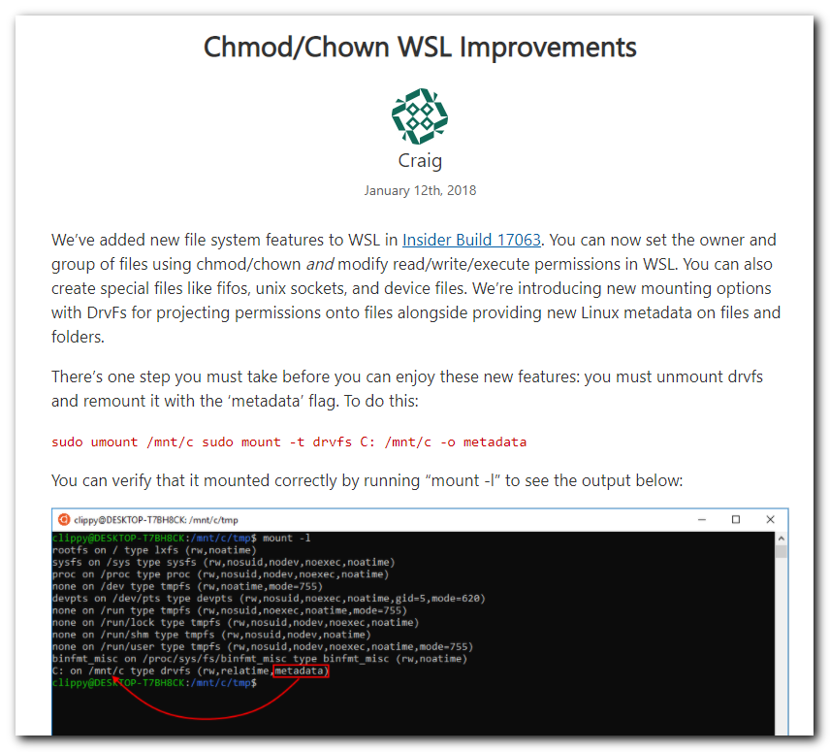

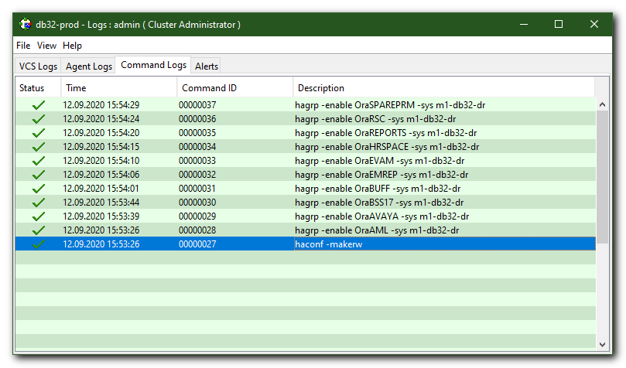

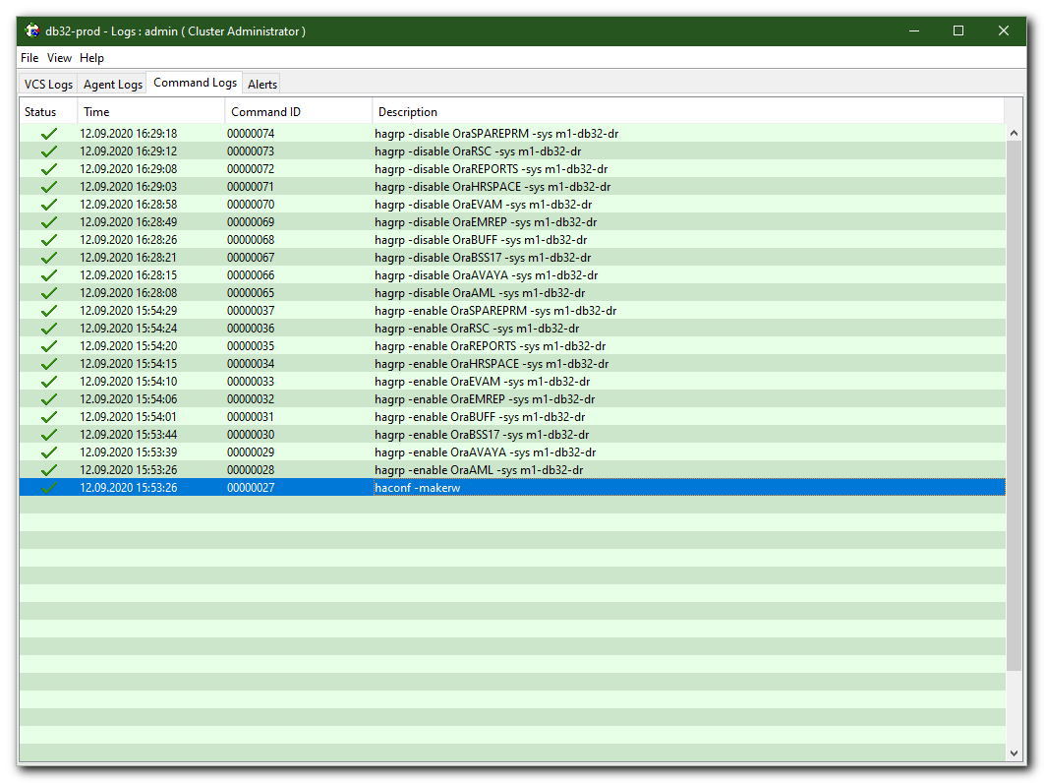

Ушаков Никита 2:12 PM
@s.belogrud @n.bugrov Коллеги, добрый день. в 15-00 начнём?

Светличный Алексей 2:20 PM
Никита должен быть, если что я подстрахую

Бугров Никита 2:21 PM
Я пока на обучении

Светличный Алексей 2:48 PM
ds-db32-prod2 - сервер без нагрузки. Можно брать в работу.
Предварительно обязательно активировать m1-db32-dr для возможности переезда туда баз, если что-то пойдет не так

Ушаков Никита 2:49 PM
@s.belogrud Сергей? Надо активировать, и погасить ds-db32-prod2, как погасишь, напиши, буду добавлять память

Белогруд Сергей:house_with_garden: 2:50 PM
Ок.

Светличный Алексей 2:50 PM
я в магазин пока заскочу, ноут с собой. Если что звоните

Белогруд Сергей:house_with_garden: 3:00 PM
Отправил сервер выключаться.

Ушаков Никита 3:03 PM
Сервер погас, добавляю память

Ушаков Никита 3:15 PM
Добавил. Запустилось корректно, видит 768 гигабайт оперативки
3:15
ОС загружается

Белогруд Сергей:house_with_garden: 3:16 PM
Подключился к серверу по ssh. Донастраиваю.

Ушаков Никита 3:28 PM
@s.belogrud Сергей, отпишись, пожалуйста, когда закончишь.

Белогруд Сергей:house_with_garden: 3:32 PM
Закончил.
В nagios проверка ntp на сервере красная. Само время корректное. Поставлю downtime до понедельника до 15:00. Чтобы разбираться с ней в рабочее время.

Ушаков Никита 3:34 PM
@n.bugrov @a.svetlichniy Коллеги, есть возможность проверить с вашей стороны - всё ок?

Бугров Никита 3:35 PM
Смотрю

Белогруд Сергей:house_with_garden: 3:36 PM
Проверка ntp позеленела в nagios.

Светличный Алексей 3:36 PM
@s.belogrud m1 вернул в неактивное состояние?

Белогруд Сергей:house_with_garden: 3:37 PM
Вернул.

Бугров Никита 3:38 PM
MemTotal: 792063396 kB
HugePages_Total: 309399

Светличный Алексей 3:39 PM
Похоже
3:39
Было150к

Бугров Никита 3:39 PM
Да, на prod1 — 154585

Ушаков Никита 3:40 PM
Коллеги, считаем что работы окончены?

Бугров Никита 3:41 PM
Сергей @s.belogrud, проверь, пожалуйста, что m1-db32-dr деактивирован.
3:41
А, вижу, уже спрашивали. Пардон.
3:41
Тогда всё

Ушаков Никита 3:41 PM
Коллеги, всем спасибо, расходимся до следующей добавки.

Белогруд Сергей:house_with_garden: 3:42 PM
:ok_hand::grin:

#
# Changes for increased amount of memory was applyed.
#
[support@centos jet]$ export ANSIBLE_CONFIG=ansible.cfg ; ansible-playbook oracle.yml -i list_of_hosts --become --tags tuning --diff --extra-vars "ansible_user=bsv ansible_password=$(pass common/linux) ansible_sudo_pass=$(pass common/linux) ansible_ssh_common_args='-oStrictHostKeyChecking=no -oPubkeyAuthentication=no -oUserKnownHostsFile=/dev/null'" | tee -a ./output/$(date +%Y%m%d-%H%M).playbook.log.txt
[WARNING]: file /mnt/share/work/vm-gitlab01.tcsbank.ru/jet/roles/oracle/tasks/add_di.yml is empty and had no tasks to include

PLAY [all] *******************************************************************************************************************************************************************

TASK [Gathering Facts] *******************************************************************************************************************************************************
ok: [ds-db32-prod2.tcsbank.ru]

TASK [oracle : Oracle OS sysctl tuning] **************************************************************************************************************************************
ok: [ds-db32-prod2.tcsbank.ru] => (item={'value': 500, 'key': u'vm.dirty_expire_centisecs'})
ok: [ds-db32-prod2.tcsbank.ru] => (item={'value': 0, 'key': u'vm.dirty_ratio'})
ok: [ds-db32-prod2.tcsbank.ru] => (item={'value': 0, 'key': u'vm.dirty_background_ratio'})
ok: [ds-db32-prod2.tcsbank.ru] => (item={'value': u'256 131072 100 512', 'key': u'kernel.sem'})
ok: [ds-db32-prod2.tcsbank.ru] => (item={'value': 4096, 'key': u'kernel.shmmni'})
ok: [ds-db32-prod2.tcsbank.ru] => (item={'value': 6815744, 'key': u'fs.file-max'})
ok: [ds-db32-prod2.tcsbank.ru] => (item={'value': 3145728, 'key': u'fs.aio-max-nr'})
ok: [ds-db32-prod2.tcsbank.ru] => (item={'value': 2147483648, 'key': u'vm.dirty_bytes'})
ok: [ds-db32-prod2.tcsbank.ru] => (item={'value': 1, 'key': u'vm.swappiness'})
ok: [ds-db32-prod2.tcsbank.ru] => (item={'value': 0, 'key': u'kernel.numa_balancing'})
ok: [ds-db32-prod2.tcsbank.ru] => (item={'value': u'9000 65001', 'key': u'net.ipv4.ip_local_port_range'})
ok: [ds-db32-prod2.tcsbank.ru] => (item={'value': 209715200, 'key': u'vm.dirty_background_bytes'})

TASK [oracle : Set shmmax = (RAM in bytes - 1)] ******************************************************************************************************************************
changed: [ds-db32-prod2.tcsbank.ru]

TASK [oracle : Set shmall = ((shmmax - 1GB) / shmni))] ***********************************************************************************************************************
changed: [ds-db32-prod2.tcsbank.ru]

TASK [oracle : Set Huge Pages = (default 80%) RAM] ***************************************************************************************************************************
changed: [ds-db32-prod2.tcsbank.ru]

TASK [oracle : Set vm.min_free_kbytes] ***************************************************************************************************************************************
skipping: [ds-db32-prod2.tcsbank.ru]

TASK [oracle : oracle limits tuning] *****************************************************************************************************************************************
ok: [ds-db32-prod2.tcsbank.ru] => (item={u'type': u'soft', u'limit': u'nofile', u'value': 1048576})
ok: [ds-db32-prod2.tcsbank.ru] => (item={u'type': u'hard', u'limit': u'nofile', u'value': 1048576})
ok: [ds-db32-prod2.tcsbank.ru] => (item={u'type': u'soft', u'limit': u'nproc', u'value': 1048576})
ok: [ds-db32-prod2.tcsbank.ru] => (item={u'type': u'hard', u'limit': u'nproc', u'value': 1048576})
ok: [ds-db32-prod2.tcsbank.ru] => (item={u'type': u'soft', u'limit': u'stack', u'value': 10240})
ok: [ds-db32-prod2.tcsbank.ru] => (item={u'type': u'hard', u'limit': u'stack', u'value': 32768})
changed: [ds-db32-prod2.tcsbank.ru] => (item={u'type': u'soft', u'limit': u'memlock', u'value': u'712856678'})
changed: [ds-db32-prod2.tcsbank.ru] => (item={u'type': u'hard', u'limit': u'memlock', u'value': u'712856678'})

PLAY RECAP *******************************************************************************************************************************************************************
ds-db32-prod2.tcsbank.ru : ok=6 changed=4 unreachable=0 failed=0 skipped=1 rescued=0 ignored=0

[support@centos jet]$

